March 5, 2021

The Honorable Tasha Boerner Horvath
California State Assembly
State Capitol Building
Sacramento, CA 95814

RE: AB 341 (Boerner Horvath) – Support

Dear Assemblymember Boerner Horvath:

On behalf of the California Women’s Law Center, we write in support of AB 341 which will provide additional protections for victims of sexual assault by requiring that evidence proffered from social media accounts be evaluated by a judge before they are admissible.

Social media has become prolific. In sexual assault cases, defense attorneys have turned to mining social media accounts of sexual assault victims to discover information that can be used against the victim during trial. Under the current Rape Shield Law, if evidence of sexual conduct of the complaining witness is offered to attack that witness’s credibility in a rape prosecution, the defense attorney must follow specific procedures before this information can be admitted.

AB 341 would narrowly expand the current Rape Shield Law to include situations where a defendant offers evidence about the sexual conduct of a witness from a social media account that is not related to the alleged offense. If such evidence is introduced, the defense would be required to produce a written motion showing the relevancy of the social media evidence. AB 341 will protect the privacy of the victim, and reduce blatant attempts to embarrass, shame or discourage a victim from testifying against their perpetrator.

CWLC’s mission is to create a more just and equitable society by breaking down barriers and advancing the potential of women and girls through transformative litigation, policy advocacy, and education. We prioritize ensuring survivors of sexual assault have access to all avenues of justice available to them.

For these reasons, the California Women’s Law Center supports AB 341.
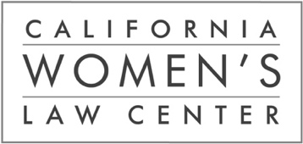
Sincerely,

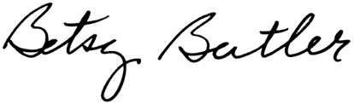
Betsy Butler
Executive Director
Board of Directors

Board Co-President
Mira El Sonbaty
Fox Corporation

Board Co-President
Diana Hughes Leiden
Winston & Strawn LLP

Board Treasurer
Edie Mermelstein, Esq.
FEM Law Group

Board Secretary
Pamela Palmer
Troutman Pepper

Immediate Past-President
Lois Thompson
Proskauer Rose LLP

Members
Thea S. Alli
Morgan Lewis

Stacey Armato
Atlantic Investors

Tony Blain
Blain & Associates

Christa M. Demeke
The Wonderful Company

Theane Evangelis
Gibson, Dunn & Crutcher LLP

Kevin Feldman
Feldman Capital LLC

Kerry C. Fowler
Jones Day

Victor George
Law Offices of Victor L. George

Vanessa Gomez
Kirkland & Ellis

Genie Harrison
Genie Harrison Law Firm

Esra Hudson
Manatt, Phelps & Phillips LLP

Bethany Kristovich
Munger, Tolles & Olson LLP

Laura Lively
King & Spalding

Jessica Ludd
UNAC/UHCP

Anna Menedjian
2020 Inc.

Kim Nakamaru
Global Eagle Entertainment

Amy Quartarolo
Latham & Watkins LLP

Karen Rigberg
Arnold & Porter

Executive Director
Betsy Butler

